INSTAGRAM USER ANALYTICS

Sowmiya R 

**PROJECT DESCRIPTION**

The aim is to provide a insights on the questions asked by the management team by finding marketing metrics and investor metrics in the instagram cloning database.

**APPROACH**

First of all , I had compiled a provided instagram dataset into a query compiler . Then I had understand each and every requirements with the provided requirements.

I had used a online query compiler to provide a valuable insights to the possible questions they have asked below in this analysis.

**TECH STACK**

I have used MySQL 8.0.33 and MySQL is a widely used open-source relational database management system (RDBMS) that offers several benefits when it comes to data analytics. Meanwhile can analyze to provide a valuable insights in the instagram dataset.

**INSIGHTS**

Let’s answering the each possible questions of each metrics with the mysql code as follows:

1. **MARKETING METRICS :** The marketing team wants to launch some campaigns, and they need your help with the following:

1.**Rewarding Most Loyal Users:** Finding the 5 oldest users of the Instagram from the database provided with the joined date.

|  |
| --- |
| SELECT *FROM users  ORDER BY created_at DESC LIMIT 5; |

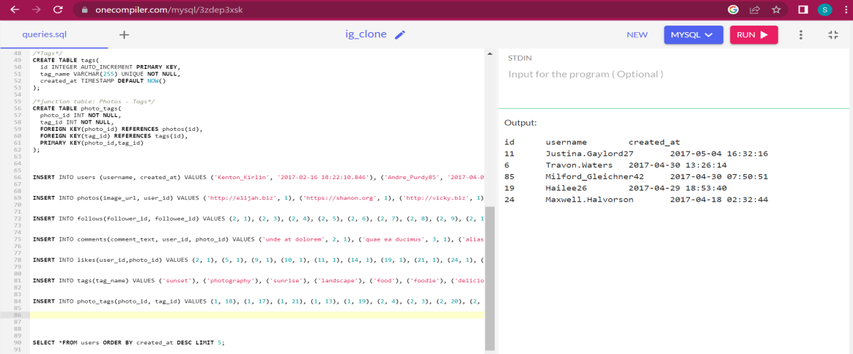

Oldest 5 users joining date with their username and user id:

|  |  |  |
| --- | --- | --- |
| id | username | created_at |
| 38 | Jordyn.Jacobson2 | 2016-05-14 07:56:26 |
| 63 | Elenor88 | 2016-05-08 01:30:41 |
| 67 | Emilio_Bernier52 | 2016-05-06 13:04:30 |
| 80 | Darby_Herzog | 2016-05-06 00:14:21 |
| 95 | Nicole71 | * + 1. 7:30:22 |

**2.Remind Inactive Users to Start Posting:** By sending them promotional emails to post their 1st photo. Find the users who have never posted a single photo on Instagram.

select id,username

from users

WHERE id NOT IN (SELECT user_id FROM photos);

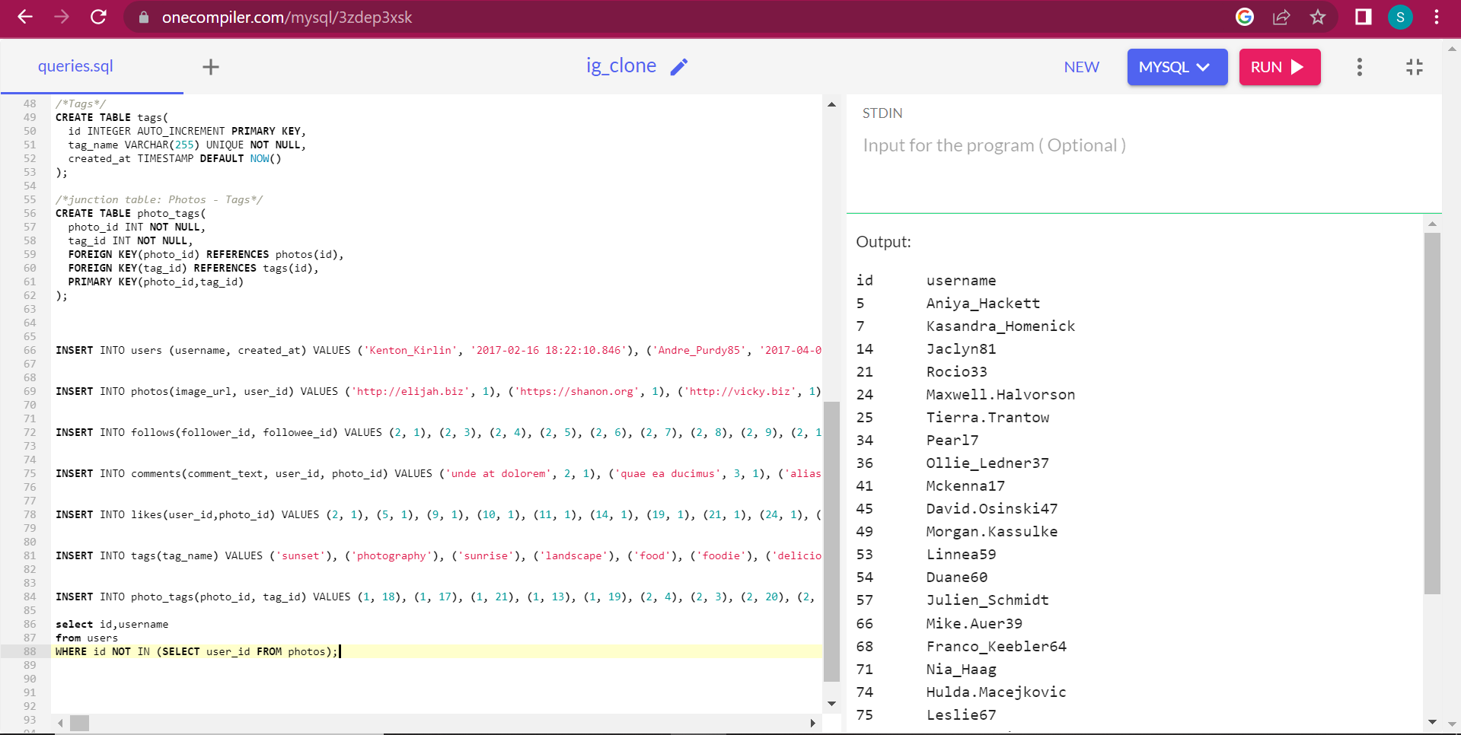

There are total 26 users who never posted a photo on the platform:

|  |  |
| --- | --- |
| id | username |
| 5 | Aniya_Hackett |
| 7 | Kasandra_Homenick |
| 14 | Jaclyn81 |
| 21 | Rocio33 |
| 24 | Maxwell.Halvorson |
| 25 | Tierra.Trantow |
| 34 | Pearl7 |
| 36 | Ollie_Ledner37 |
| 41 | Mckenna17 |
| 45 | David.Osinski47 |
| 49 | Morgan.Kassulke |
| 53 | Linnea59 |
| 54 | Duane60 |
| 57 | Julien_Schmidt |
| 66 | Mike.Auer39 |
| 68 | Franco_Keebler64 |
| 71 | Nia_Haag |
| 74 | Hulda.Macejkovic |
| 75 | Leslie67 |
| 76 | Janelle.Nikolaus81 |
| 80 | Darby_Herzog |
| 81 | Esther.Zulauf61 |
| 83 | Bartholome.Bernhard |
| 89 | Jessyca_West |
| 90 | Esmeralda.Mraz57 |
| 91 | Bethany20 |

**3.Declaring Contest Winner:** The team started a contest and the user who gets the most likes on a single photo will win the contest now they wish to declare the winner. Identify the winner of the contest and provide their details to the team.

SELECT username, photos.id, photos.image_url, count(*) as total FROM photos inner join likes on likes.photo_id = photos.id

inner join users on photos.user_id = users.id

GROUP BY photos.id

ORDER BY total DESC LIMIT 1;

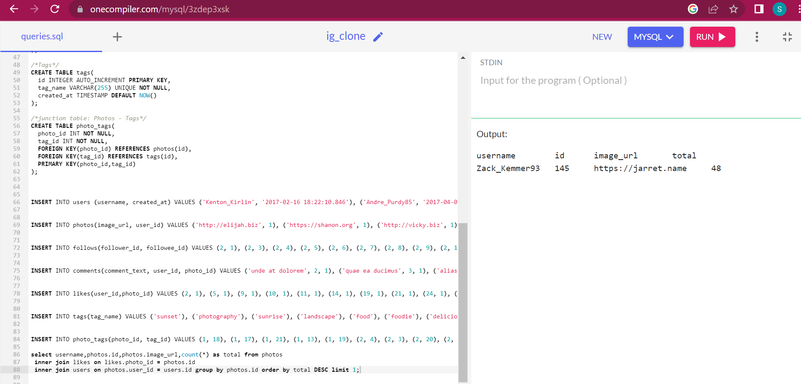

User with ID: Zack_kemmer93 has won the contest with 48 likes for a single photo he had posted.

|  |  |  |  |
| --- | --- | --- | --- |
| username | id | image_url | total |
| Zack_Kemmer93 | 145 | https://jarret.name | 48 |

**4. Hash tag Researching:** A partner brand wants to know, which hash tags to use in the post to reach the most people on the platform. Identify and suggest the top 5 most commonly used hash tags on the platform.

SELECT tags.tag_name,count(*) as total FROM photo_tags

join tags on photo_tags.tag_id=tags.id

GROUP BY tags.id

ORDER BY total ASC LIMIT 6;

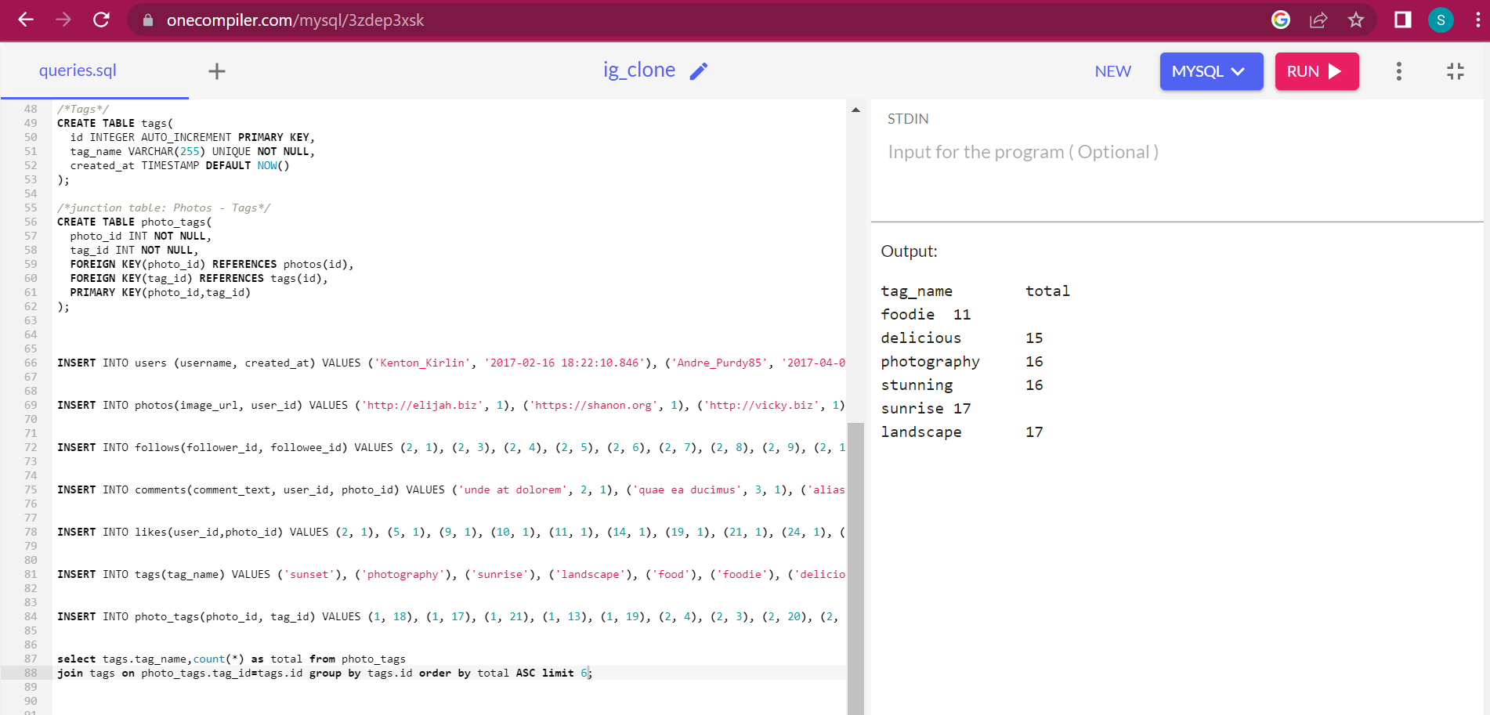

|  |  |
| --- | --- |
| tag_name | total |
| foodie | 11 |
| delicious | 15 |
| photography | 16 |
| stunning | 16 |
| sunrise | 17 |
| landscape | 17 |

1. **Launch AD Campaign:** The team wants to know, which day would be the best day to launch ADs. What day of the week do most users register on? Provide insights on when to schedule an ad campaign.

SELECT day_week, count(day_week) AS date_week

FROM (SELECT dayname(created_at) AS day_week

FROM users) as table1

GROUP BY day_week

ORDER BY date_week DESC LIMIT 7;

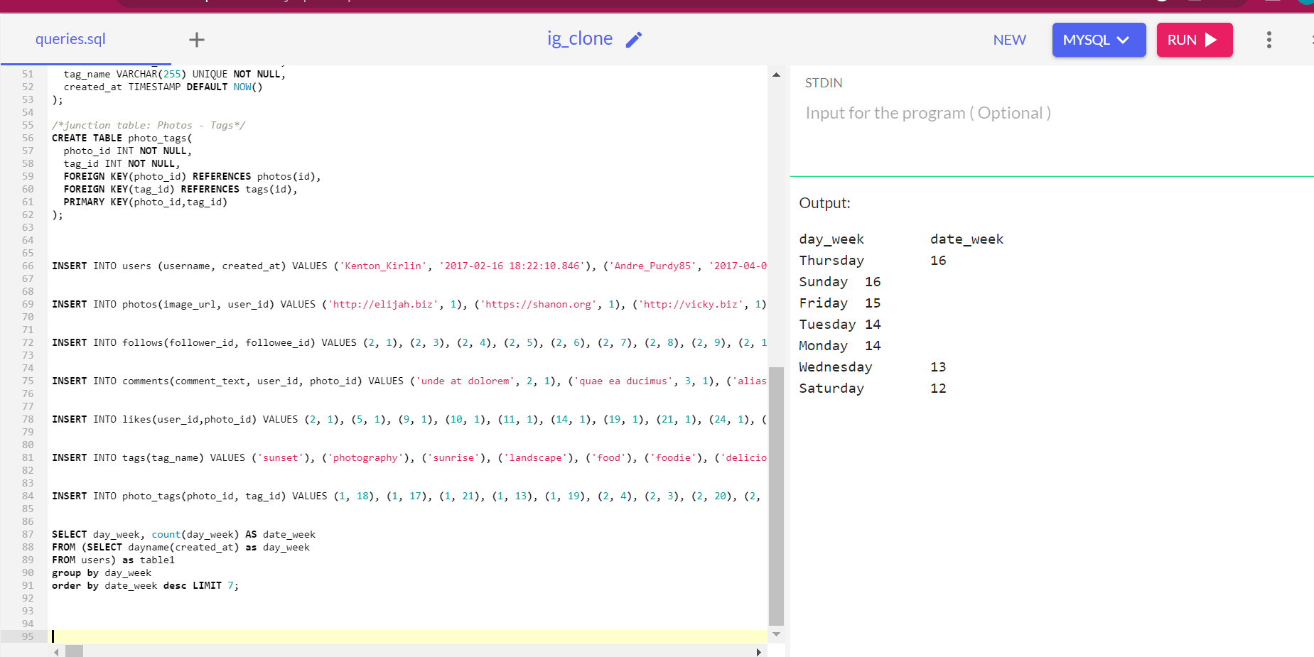

|  |  |  |
| --- | --- | --- |
| day_week |  | date_week |
| Thursday |  | 16 |
| Sunday |  | 16 |
| Friday |  | 15 |
| Tuesday |  | 14 |
| Monday |  | 14 |
| Wednesday |  | 13 |
| Saturday |  | 12 |

Thursdays and Sundays are two days with most user signup on Instagram.

**B) Investor Metrics:** Our investors want to know if Instagram is performing well and is not becoming redundant like Facebook, they want to assess the app on the following grounds

1. **User Engagement:** Are users still as active and post on Instagram or they are making fewer posts. Provide how many times does average user posts on Instagram. Also, provide the total number of photos on Instagram/total number of users.

**Total number of photos on Instagram / Total number of users**

SELECT (SELECT count(*) FROM photos)/(SELECT count(*) FROM users) AS average;

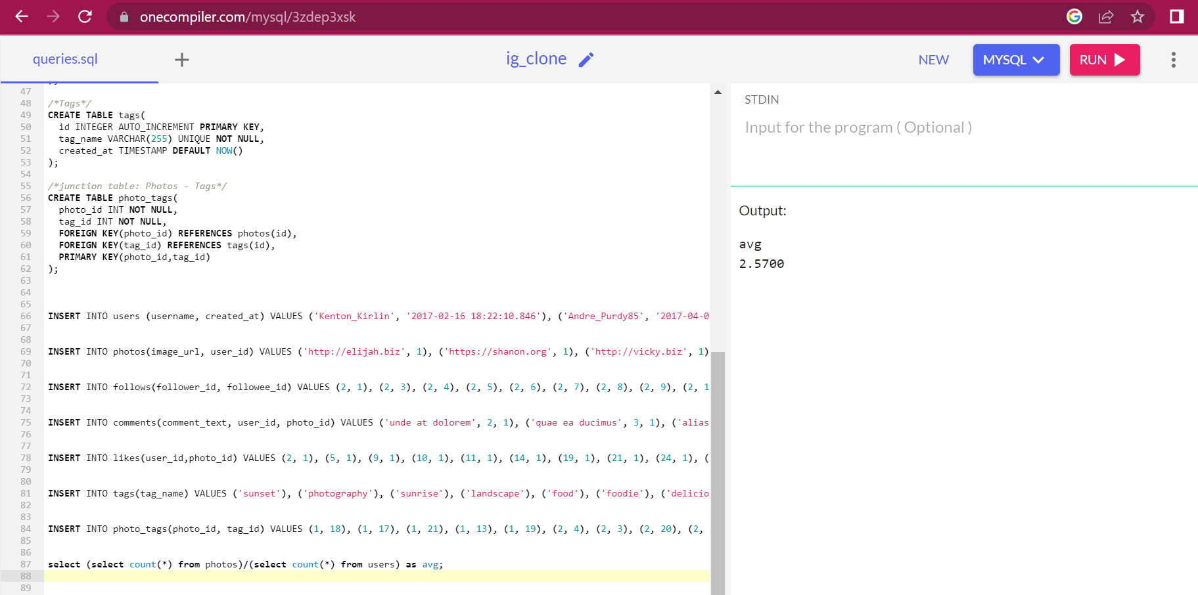

|  |
| --- |
| average |
| 2.5700 |

**2. Bots & Fake Accounts**: The investors want to know if the platform is crowded with fake and dummy accounts. Provide data on users (bots) who have liked every single photo on the site (since any normal user would not be able to do this).

SELECT user_id, username, count(*) AS count_likes FROM users

inner join likes on users.id = likes.user_id

GROUP BY likes.user_id

HAVING count_likes = (SELECT count(*) FROM photos) ;

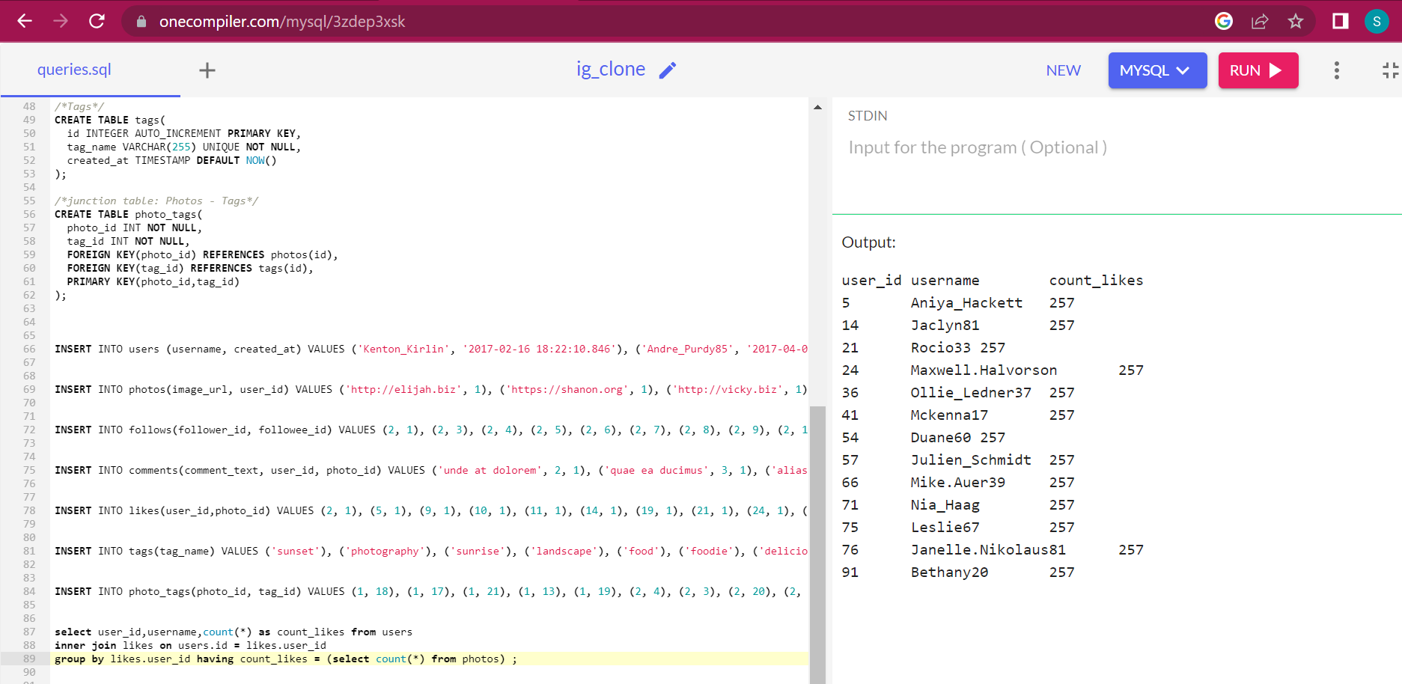

user_id username count_likes

5 Aniya_Hackett 257

14 Jaclyn81 257

21 Rocio33 257

24 Maxwell.Halvorson 257

36 Ollie_Ledner37 257

41 Mckenna17 257

54 Duane60 257

57 Julien_Schmidt 257

66 Mike.Auer39 257

71 Nia_Haag 257

75 Leslie67 257

76 Janelle.Nikolaus81 257

91 Bethany20 257

**RESULT**

By this Instagram user analysis project I had gained a knowledge about the dataset being analyzed, and the queries and techniques employed. The interpretation and action ability of the results would also depend.

**DRIVE LINK**



https://drive.google.com/file/d/10-vCx1VXrsek946TH1n2bWMbeyWHhGEV/view?usp=drive_link